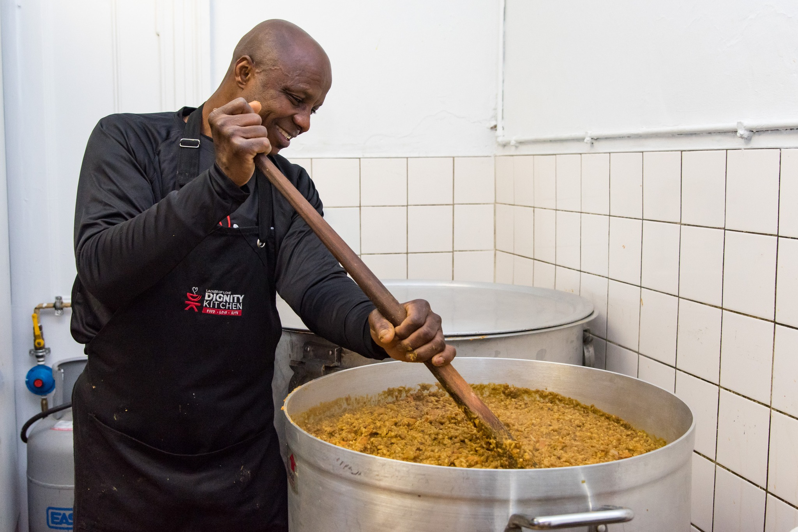
Proposal of Themba Givers
WEB DEVELOPMENT - WEDE5020
Phumelele SkosanaST10483344
Table of Contents
Organisation Overview 2
Website Goals and Objectives 2
Current Website Analysis 2
Proposed Website Features and Functionality 3
Design and User Experience 3
Technical Requirements 3
Timeline and Milestones 3
Budget 4

Organisation Overview
Themba Givers is a non-profit organization which was founded in 2020 during the outbreak of COVID-19. This is because most people lost their jobs around that outbreak which meant people needed basic needs like food and shelter and that’s how Themba Givers came about. This NPO is led by Themba Sibiya as well as volunteers of the Diepsloot community which want to help the unfortunate get their basic needs as it is within their right.

Website Goals and Objectives
The goal of this website is to inform and educate the public about the work that Themba Givers is doing within the communities. The reason why this is done is because this helps the NPO grow by reaching out to people and they donate money to the NPO in order for the NPO to continue doing the work that they are doing which is handing out food parcels and hampers for the unfortunate and it does offer shelter for those who have lost their homes during the period of COVID-19 or natural disasters like the Durban floods etc.

Current Website Analysis
There is currently no website about Themba Givers, however there is a weakness in the NPO which is without the help of the volunteers and the donations of people that are doing well in the community the unfortunate cannot get helped so the NPO depends on the people and not the CEO itself.
For improvement we can use this website to reach out to more people in the country or world for them to see our work and donate or lend a hand to help more people in more communities etc.

Proposed Website Features and Functionality
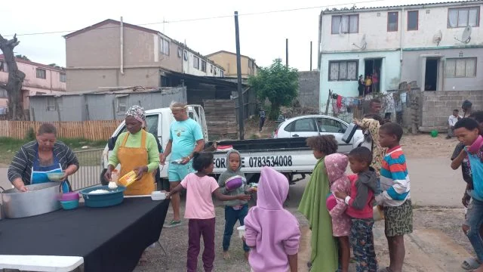
Essential features for this website would be the homepage, about us page, contact page, products and the type of services we offer as well as the functionality of the desired functionality of the website.

Design and User Experience
The overall colour scheme of the website will be grey. The typography that will be used will be Times New Roman. It will contain 5 web pages. These will be included in the wireframes.

Technical Requirements
The programming languages that will be used will be mainly HTML for part 1, CSS for part 2 to improve the styling of the website. Then finally for part 3, JavaScript will be integrated to enhance the functionality of the app.

Timeline and Milestones
Part 1 will be submitted on the 24th of August 26’ then Part 2 will be submitted on 18th of September 26’ and finally Part 3 submissions are still to be confirmed.

Budget
For this website realistically we would budget around R 1 500 because there is not much labour as there will be mostly pictures and banking details for potential donators.

Wireframes
Wireframe 1:
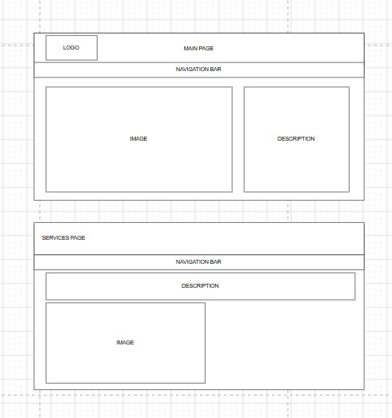

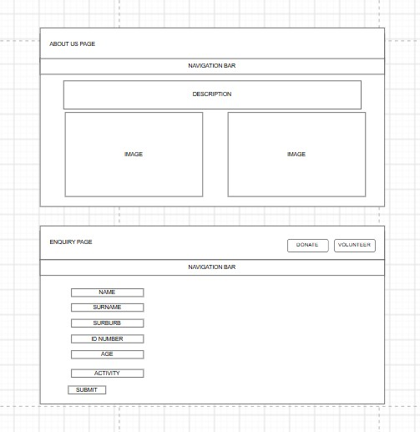
Wireframe 2:

Wireframe 3:
